**PROJECT TOPIC: EduTek**

**Project Group Members:**

**1. Anik Roy (M (03) / 2115800003)**

**2. Ayush Tiwari (M (08) / 2115800008)**

**3. Luvkush Sharma (M (13) /21158000015)**

**Project Supervisor:** Mr. Sanjay Madan

**About the Project:**  EduTek is a comprehensive Learning Management System (LMS) designed to address the evolving needs of modern education. It leverages cutting-edge technologies to provide a secure, scalable, and user-friendly platform for both learners and educators. Built on a solid backend foundation with Node.js, Express.js, MongoDB, Rtk Query, and Socket.io, EduTek ensures efficient data management, seamless real-time communication, and optimized database interactions. The frontend is powered by Next.js 13, Typescript, Formik, and Yup, delivering a highly responsive and interactive user interface.

One of the core features of EduTek is its robust content protection system. With DRM encryption through its Video Cipher, EduTek safeguards learning materials against unauthorized access, ensuring content integrity. Additionally, the platform incorporates integrated payment gateways, allowing for secure and hassle-free transactions when purchasing courses.

EduTek is equipped with both admin and user dashboards, providing real-time notifications, course management, and user engagement analytics. The system fosters an interactive learning environment with a dedicated Q&A platform for live discussions between students and instructors. Learners can also submit feedback and reviews to enhance the learning experience.

Furthermore, the platform includes live video classes, enabling real-time instruction and enhancing the overall educational experience. EduTek is a powerful tool that redefines digital learning, focusing on security, engagement, and accessibility for users worldwide.

**Motivation:** The motivation behind EduTek stems from the growing need for accessible, secure, and interactive online education platforms in a rapidly digitizing world. Traditional learning methods often lack flexibility and engagement, while existing platforms face challenges in content protection and real-time interaction. EduTek aims to bridge this gap by providing a comprehensive, secure, and user-centric Learning Management System that prioritizes content security, seamless communication, and a rich learning experience. By integrating modern technologies, EduTek empowers educators and learners to connect more effectively in the digital education landscape.

**Innovation**:

1. Address the need for secure online education platforms, protecting content with advanced DRM encryption.
2. Provide a user-friendly, interactive learning environment for both educators and learners.
3. Enhance engagement through real-time features like live video classes and interactive Q&A sessions.
4. Offer flexibility and accessibility in digital learning, bridging gaps found in traditional methods.
5. Improve the overall learning experience by integrating seamless payment gateways and real-time notifications for efficient course management.

**Project Planning:**

1. **Requirement Gathering and Analysis:**

* Initial discussions with stakeholders to identify essential features, including security protocols, real-time interactions, and user-friendly interfaces. Research was conducted to ensure the integration of the latest technologies like DRM encryption and real-time video streaming.

1. **Architecture Design:**

* The system architecture was carefully planned, incorporating backend technologies such as Node.js, Express.js, and MongoDB for secure data handling, along with a scalable frontend built using Next.js and Typescript.

1. **Development Phases:**

* The project was divided into sprints, with each sprint focusing on specific features like video ciphering, payment gateway integration, and dashboard development. Regular code reviews and testing were conducted to ensure quality.

1. **Testing and Quality Assurance:**

* Extensive testing, including unit tests, integration tests, and security audits, was performed to ensure the platform’s stability, performance, and security, particularly with features like real-time communication and content protection.

1. **Deployment:**

* Following successful testing, EduTek was deployed for initial users, with thorough documentation to guide educators and learners through the platform's features. Continuous monitoring ensured a smooth launch.

1. **Maintenance and Updates:**

* Post-deployment, a maintenance schedule was set to ensure the platform remains up-to-date with the latest security patches, feature enhancements, and bug fixes. Regular updates are planned based on user feedback and evolving technology standards to maintain optimal performance and user satisfaction.

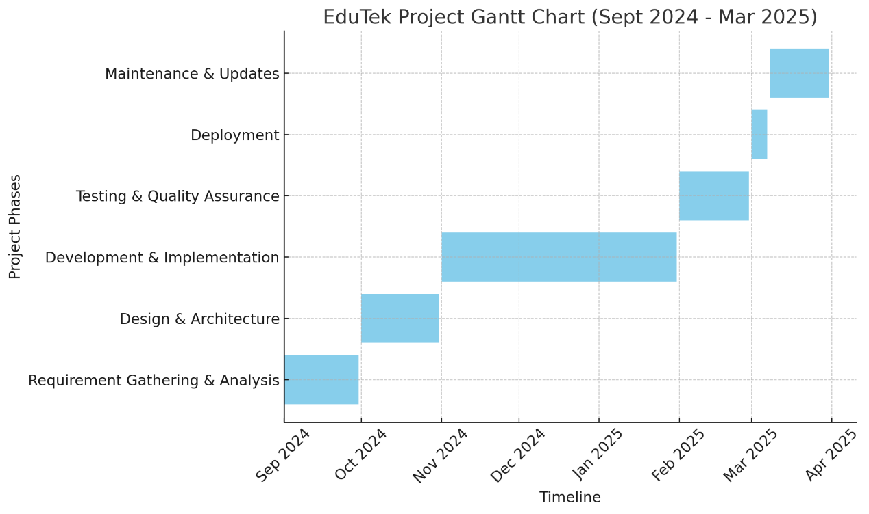

**Tools required:**

* **Hardware Requirements**
  + **Processor**: Intel Core i5 or higher / AMD Ryzen 5 or higher
  + **RAM**: 16 GB or higher (for running Node.js, MongoDB, and frontend development simultaneously)
  + **Storage**: 512 GB SSD (for faster read/write speeds)
  + **Graphics**: Integrated or dedicated graphics card (for handling frontend/UI rendering tasks)
  + **Operating System**: Windows 10/11, macOS, or Linux (Ubuntu preferred for server-like environments)
  + **Network**: High-speed internet connection for accessing cloud services, collaboration tools, and version control systems (e.g., GitHub)

* **Software Requirements:** 
  + **Backend**: Node.js, Express.js, MongoDB, Rtk Query, and Socket.io for server-side operations, real-time communication, and data management.
  + **Frontend**: Next.js 13, Typescript, Formik, Yup, and React for building a responsive and interactive user interface.
  + **Testing & Quality Assurance**: Jest, Mocha, Postman for unit/integration testing, and Selenium/Cypress for end-to-end testing.
  + **Security & Content Delivery**: DRM encryption services, SSL certificates for secure content streaming.
  + **Version Control & CI/CD**: Git, GitHub/GitLab, Jenkins for version control, collaboration, and continuous deployment.

**Signature of Project Supervisor: _____________­­_**